Youth Zone Survey Results
March 2026
All individuals active with the 412 Youth Zone had the opportunity to participate in a survey in early 2026. Surveys were administered on paper and online.
204 unique youth (of [TOTAL ACTIVE — fill in denominator] total active) responded to the survey, for a response rate of [RESPONSE RATE %]. Most respondents were age 18 or older. About half (49%) of the respondents who reported their age were between 18 and 20 years old, and 40% were 21 to 23 years old. Only 10% were 16 or 17 years old, down from 16% in 2025.
Survey Respondents by Age
Age | Count
16-17 years old | 18
18-20 years old | 88
21-23 years old | 72
Unknown | 26
Total | 204
More females (54%) responded to the survey than males (34%). Twenty-one transgender and non-binary youth also responded to the survey (12%), up from 12 youth (7%) in 2025. As represented in the table below, youth of all genders selected a variety of terms to describe their sexual orientation. Young women were more likely than their male peers to identify as LGBTQ (38% v. 21%), and 38% of respondents identified as LGBTQ in some way.
Survey Respondents by Gender and Sexual Orientation
Sexual Orientation | Female | Male | Trans, Non-binary | Total
Number of Youth | 95 | 61 | 21 | 177
Heterosexual/Straight | 49 | 44 | 0 | 93
Bisexual | 16 | 4 | 2 | 22
Gay, Lesbian, or Same Gender Loving | 8 | 4 | 6 | 18
Asexual | 7 | 3 | 4 | 14
I don't understand the question | 6 | 2 | 1 | 9
Pansexual | 3 | 1 | 5 | 9
I am not sure yet | 3 | 1 | 0 | 4
Demisexual | 1 | 0 | 1 | 2
Queer | 1 | 0 | 1 | 2
Mostly heterosexual | 0 | 1 | 0 | 1
Unknown | 1 | 1 | 1 | 3
The tables below display respondents’ racial identities and genders. Please note: Youth Zone participants’ racial identities are self-reported and reflect the full range of how young people describe themselves.
Just over half of survey respondents identified as Black when each youth was counted once, while 28% identified as White, 17% as Multiracial, and 3% reported another single racial identity. When full or partial identities are counted using the unique respondent total, 62% of youth identified as Black, 31% as White, 11% as Multiracial, and 6% as Hispanic or Latinx. This marks a change from the prior year, when 66% of respondents identified as Black either fully or partially. White identification increased from 27% to 31%, while Multiracial identification remained steady at 11% and Hispanic or Latinx identification rose from 4% to 6%.
Youth by Race and Gender (all Youth are Counted Once)
Race/Ethnicity | Female | Male | Trans, Non-binary | Total | Percent
Black | 53 | 34 | 3 | 90 | 52%
White | 20 | 17 | 11 | 48 | 28%
Multiracial | 17 | 7 | 6 | 30 | 17%
Other single racial identity | 2 | 3 | 0 | 5 | 3%
Total | 92 | 61 | 20 | 173
Note: If a youth selected 2 or more race tokens, they are attributed to "Multiracial" only.
Youth with Full or Partial Racial Identities (Some Youth Are Counted Multiple Times)
Race/Ethnicity | Female | Male | Trans, Non-binary | Total | Percent
Black | 62 | 39 | 6 | 107 | 62%
White | 24 | 18 | 11 | 53 | 31%
Multiracial | 11 | 3 | 5 | 19 | 11%
Hispanic or Latinx | 7 | 3 | 1 | 11 | 6%
Asian | 0 | 1 | 0 | 1 | 1%
Native American or Native Hawaiian | 1 | 2 | 1 | 4 | 2%
Total | 105 | 66 | 24 | 195

FINDINGS

Relationships with Coach
90% of youth reported their coaches were trustworthy, and 90% indicated their coach values their opinions about their life — both consistent with February 2025. However, ratings for coach availability and reliability declined more notably this year: “Is available to me when I need them” fell 8 percentage points to 80%, and “Is reliable” fell 5 percentage points to 84%, the lowest ratings recorded for those items across all survey cycles shown in the table below.
Among the responses where youth did not rate their coaches in the top two categories, most scores indicated their coach Sometimes exhibits the listed characteristic; the availability and reliability items drew the most non-top-2 responses, consistent with the declines noted above. A small number of youth said their coach Rarely or Never exhibits one or more of these qualities.
Satisfaction Ratings for Youth Coaches Over Time
My Youth Coach... | % Often or All the Time
 | Sep-19 | Mar-22 | Feb-23 | Feb-24 | Feb-25 | Mar-26
n | n=154 | n=103 | n=128 | n=142 | n=167 | n=204
Is trustworthy | 94% | 91% | 95% | 95% | 90% | 90%
Is reliable | 92% | 90% | 88% | 93% | 89% | 84%
Values my opinions about my life | 94% | 91% | 91% | 93% | 91% | 90%
Is available to me when I need them | 85% | 88% | 88% | 91% | 88% | 80%
Makes me feel heard and understood | 92% | 90% | 92% | 91% | 89% | 86%
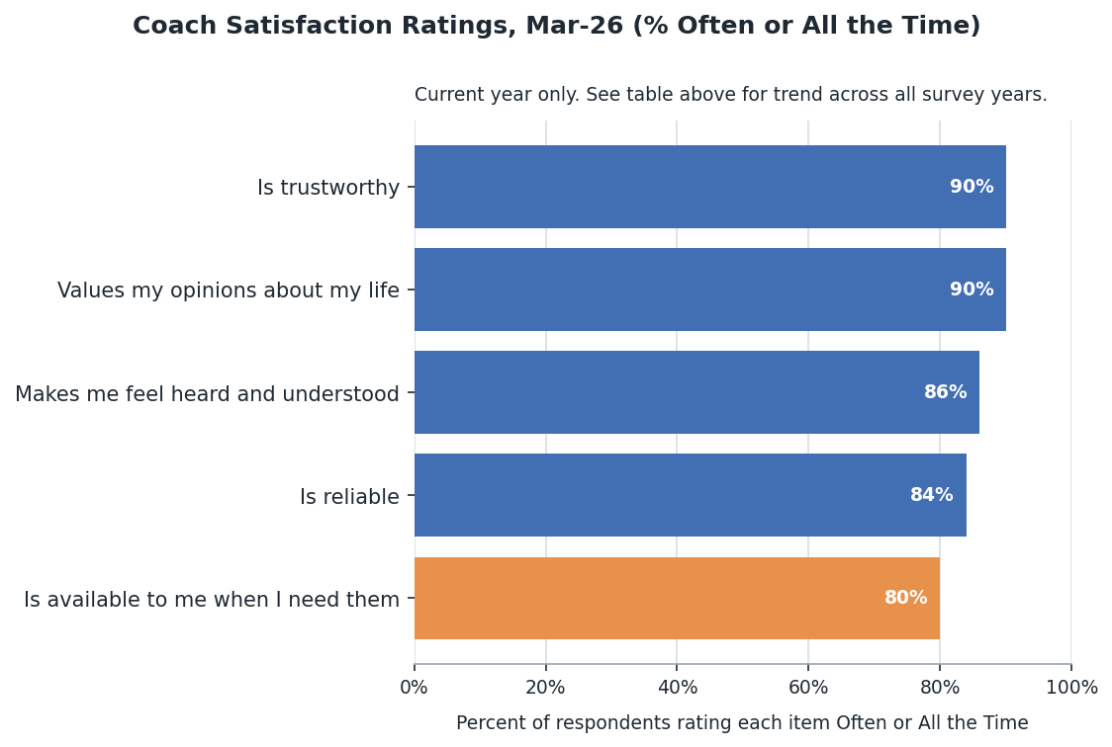
Most respondents rated the amount of communication with their coach positively. 85% reported the amount was a Good amount, while 14% (24 youth) reported it was Not enough and 2% reported Too much. This is a slight increase from February 2025, when 11% (19 youth) reported their communication was Not enough.
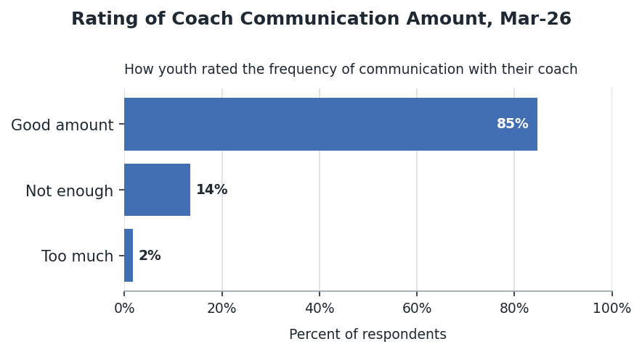
Among youth who rated communication a Good amount, nearly half communicated 1–2 times per month (49%), about a third connected with their coach about once a week (37%), and 9% communicated almost every day.
14% of respondents (n=24) reported their communication with their coach was Not enough. Most of these youth communicated 1–2 times per month (12 youth) or less than once a month (10 youth).
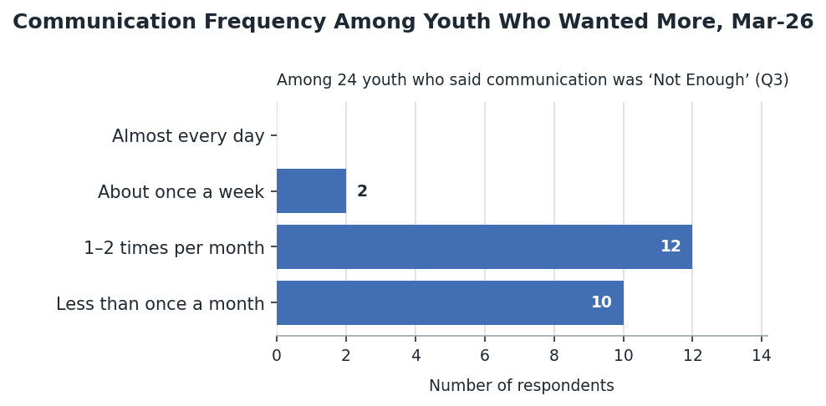

Stable Housing
Survey respondents were asked to describe whether their current housing is safe and stable, meaning they can stay there for at least the next 90 days. Youth with unstable housing were then asked where they are currently sleeping.
About 70% of respondents reported safe and stable housing, a decrease of approximately 10 percentage points from 2025. Among unstably housed youth, staying with family or friends was the most commonly reported current sleeping arrangement, followed by couch surfing.
Housing Status and Current Sleeping Arrangements
Housing Status | Count | Percent | Home, w/ Family/Friends | Homeless shelter | Couch surfing | In a car | Outside | Abandoned building | Other
Safe and stable (90+ days) | 136 | 70%
Safe, but cannot stay 90 days | 22 | 11% | 6 | 3 | 3 |  |  |  | 8
Can stay 90 days, but not safe | 7 | 4% | 3 | 1 | 1
No place to stay | 28 | 15% | 9 | 5 | 9 | 2 | 4 | 3 | 5
Total | 193 | 100% | 18 | 9 | 13 | 2 | 4 | 3 | 13
Current housing status varied by age group, as shown in the chart below.
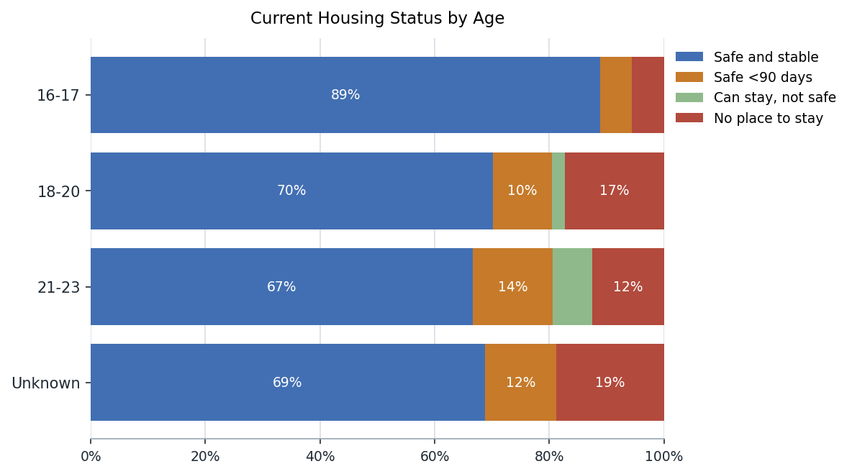
Youth ages 16–17 reported stable housing at a notably higher rate (89%) than respondents ages 18–20 and 21–23 (70% and 67%, respectively). Among 18–20 year olds, “no place to stay” was the most prevalent unstable category (17%). Youth ages 21–23 were more likely than other groups to report housing they could stay in but considered unsafe (7%).
Regardless of their current living situation, if youth experienced unstable housing in the prior six months, they were asked to share why. The table below displays the answers by age. The most common reasons youth experienced housing instability were that family or friends could no longer let them stay (49%) and feeling unsafe at home (39%), consistent with the pattern seen in the prior year. Among youth ages 21–23, feeling unsafe was the leading reason cited, while among 18–20 year olds, family or friends being unavailable was the more predominant reason.
Reasons for Unstable Housing in the Past 6 Months, by Age¹
Reason | 16-17 years old | 18-20 years old | 21-23 years old | Unknown | Total
No unstable housing in past 6 months | 16 | 62 | 48 | 21 | 147
Total youth reporting unstable housing | 2 | 26 | 24 | 5 | 57
Family/friends no longer let me stay | 0 | 19 | 7 | 2 | 28
Left - felt unsafe | 1 | 9 | 10 | 2 | 22
Other | 0 | 6 | 8 | 1 | 15
Evicted, didn't/couldn't pay rent | 0 | 3 | 3 | 2 | 8
Evicted, other reason | 1 | 2 | 2 | 1 | 6
¹ Youth could report more than one reason for experiencing unstable housing.
Note: ‘Other’ responses (n=15) included lease expiration or rent increases, unsafe or inadequate housing conditions (e.g., landlord issues, maintenance failures, pest infestation), and domestic or family safety concerns.

Employment and Education
Youth were asked to report on whether they are attending school, working, and, if not working, trying to find a job. This year:
- 46% of all respondents reported being enrolled in school, down from 53% in March 2025
- 46% of all respondents reported being employed (44% of these youth are also enrolled in school)
- 73% of respondents who are in school and unemployed are looking for a job, down from 78% in March 2025
- 82% of respondents who are not in school and unemployed are looking for a job, up from 68% in March 2025
- 22% of respondents are both not in school and unemployed, down from 26% last year; 7 of these 44 youth report not completing high school or a GED. Most of this group (82%) reported looking for work.
Among youth who reported being enrolled in school, respondents were split almost evenly between high school students (45%) and youth in college, vocational, or graduate programs (51% combined), while 4% reported being enrolled in a GED program. This is a notable change from March 2025, when about two-thirds of enrolled youth were in high school, suggesting this year’s in-school respondents were more evenly distributed across secondary and postsecondary education.
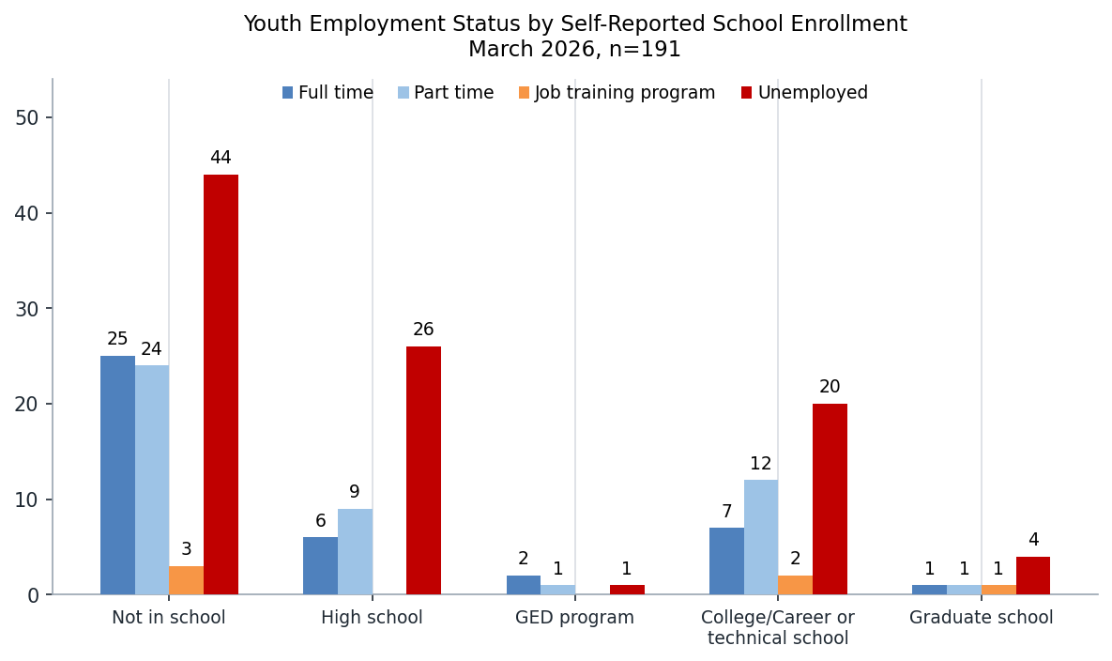
Educational Enrollment and Attainment
Group | Level | Count | Percent of All
Currently Enrolled in School | Graduate School | 7 | 4%
Currently Enrolled in School | College/Vocational | 41 | 21%
Currently Enrolled in School | GED Program | 4 | 2%
Currently Enrolled in School | High School | 42 | 22%
Not in School | Total Not in School | 97 | 51%
Not in School | College Degree or Certificate | 2 | 1%
Not in School | Some College | 15 | 8%
Not in School | HS Diploma or GED | 68 | 36%
Not in School | Some High School | 11 | 6%
Total |  | 191 | 100%
Of the 46% of survey respondents who reported being employed, 48% have been at their job for more than six months, 24% have been at their current job for three to six months, and 28% have been working there for less than three months.
Longer-term employment was more common among youth working full time than part time, and among both 18 to 20 year olds and 21 to 23 year olds the largest share of employed youth had already been in their jobs for more than six months. This suggests that once youth are connected to work, many are maintaining employment for at least part of the year.
Length of Employment for Youth Currently Employed
Job Tenure | Full time | Part time | Total
Less than 3 months | 11 | 14 | 25
3 to 6 months | 7 | 14 | 21
More than 6 months | 23 | 20 | 43
Total | 41 | 48 | 89
Employment status varied notably by age. Youth ages 16 to 17 were the least likely to be working, with most reporting they were not employed, while youth ages 21 to 23 were the most likely to report full-time work. Respondents ages 18 to 20 fell between those two groups and were more likely to report part-time than full-time employment.
Employment Status by Age
Employment Status | 16-17 years old | 18-20 years old | 21-23 years old | Unknown | Total
Full time | 0 | 16 | 22 | 3 | 41
Part time | 4 | 23 | 16 | 5 | 48
Job training program | 0 | 3 | 3 | 0 | 6
Seeking Employment | 0 | 1 | 1 | 0 | 2
Not working | 14 | 45 | 31 | 10 | 100
Seeking Employment | 10 | 33 | 24 | 7 | 74
Total | 18 | 87 | 72 | 18 | 195
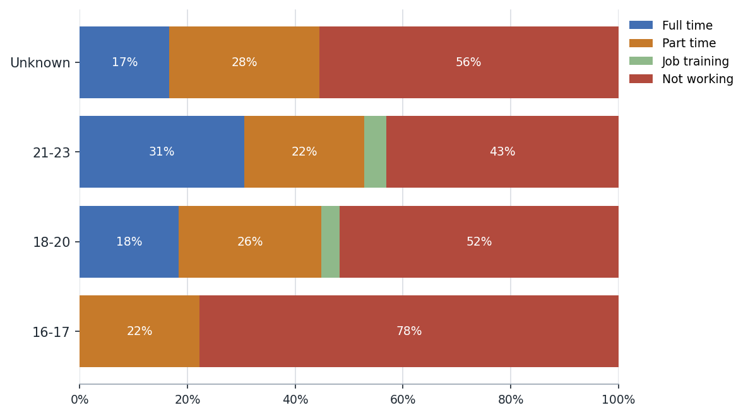
If survey respondents had trouble finding a job in the prior twelve months, they were asked to share some of the reasons they believed were contributing to those challenges. Youth were offered a multiple-choice list of reasons and could also add their own responses.
The most common challenge identified this year, reported by 41% of youth, was applying and not getting called, followed closely by transportation issues (40%) and limited work experience (36%). This represents a clear shift from March 2025, when transportation issues were the leading barrier at 32% and applying without getting called back was reported by 28% of youth. Mental or physical health remained a substantial barrier for 26% of youth, and nearly all of those reporting that challenge were age 18 or older.
Reasons Youth Have Trouble Finding Jobs (Reasons Given by 2 or More People)
Barrier | Total Youth | Percent of Youth with Barriers
Applying and not getting called | 39 | 41%
Transportation issues | 38 | 40%
Limited work experience | 34 | 36%
Mental or physical health | 24 | 26%
Weak references | 16 | 17%
Interview skills | 16 | 17%
Something else | 11 | 12%
Childcare/parenting challenges | 10 | 11%
Lack of HS diploma/GED | 8 | 9%
Criminal background | 8 | 9%
Use of drugs or alcohol | 1 | 1%
Note: Youth could select more than one option
If the survey respondent lost or left a job in the past year, they were asked to share the reason(s).
This year, the most common reason youth reported leaving a job was finding a better job, cited by 33% of youth who reported at least one reason for leaving. Twenty-eight percent reported quitting, and 26% said the job was seasonal or temporary. Among the youth who quit, the most common specific reasons were low pay or not enough hours and mental or emotional health, each reported by 8% of youth who left a job; personal or family reasons followed closely at 7%.
Unlike the prior year, quitting was not the dominant reason for job separation in this year’s data. Youth ages 18 to 20 and 21 to 23 both accounted for most reports of leaving a job, but no single age group clearly dominated the overall pattern of job separation. Sub-reasons for youth who quit are shown indented below the Quit row.
Reasons Youth Lost or Quit a Job in the Past Year (Reasons Given by 2 or More People)
Reason | Total Youth | Percent Who Left a Job | Source
Quit | 24 | 28% | Q11
Low pay or not enough hours | 7 | 8% | Q11a
Mental/emotional health | 7 | 8% | Q11a
Personal or family reasons | 6 | 7% | Q11a
Schedule conflict | 4 | 5% | Q11a
Lack of support or respect | 4 | 5% | Q11a
Transportation challenges | 4 | 5% | Q11a
Other | 4 | 5% | Q11a
Poor working conditions | 2 | 2% | Q11a
Found a better job | 28 | 33% | Q11
Seasonal/temporary | 22 | 26% | Q11
Other | 16 | 19% | Q11
Fired: Missed work | 8 | 9% | Q11
Fired: Poor performance | 5 | 6% | Q11
Pregnant or Parenting | 4 | 5% | Q11

TRANSPORTATION
Youth were also asked about whether they have a driver’s license and the type of transportation they rely on for work. Overall, 31% of respondents indicated they have a driver’s license, and an additional 9% have their learner’s permit. The likelihood a young person has their license increases with age: 17% of youth ages 16–17 have a license compared to 23% of those ages 18–20 and 44% of those ages 21–23. Compared to March 2025, license-holding increased slightly from 30% to 31%, while the learner’s-permit share remained at 9%.
Driver’s License Status by Age
Driver's License | 16-17 years old | 18-20 years old | 21-23 years old | Unknown | Total
Number of Youth | 18 | 88 | 72 | 18 | 196
Yes | 17% | 23% | 44% | 33% | 31%
Learner's Permit | 6% | 10% | 7% | 17% | 9%
No | 78% | 67% | 49% | 50% | 60%
Total | 100% | 100% | 100% | 100% | 100%
Of those with a driver’s license, 43% regularly have access to a reliable vehicle. About one-third have their own reliable vehicle, and another 10% share a reliable vehicle or can borrow one when needed. By comparison, 44% report they do not usually have access to a reliable vehicle, a slight worsening from March 2025 when 49% of licensed youth reported regular reliable vehicle access.
Drivers’ Access to a Reliable Vehicle by Age
Vehicle Access (license holders) | 16-17 years old | 18-20 years old | 21-23 years old | Unknown | Total
Own reliable vehicle | 1 | 7 | 10 | 2 | 20
Share reliable vehicle | 0 | 1 | 1 | 1 | 3
Can borrow a car | 0 | 2 | 0 | 1 | 3
Own vehicle, but unreliable | 1 | 2 | 3 | 1 | 7
Share vehicle, but unreliable | 0 | 0 | 1 | 0 | 1
No reliable vehicle access | 1 | 8 | 17 | 1 | 27
Total | 3 | 20 | 32 | 6 | 61
All youth were asked about the primary way they get to work when they are employed. The majority rely on bus or other public transportation, reported by 68% of employed youth. Another 11% indicated they use a combination of non-bus, non-driving methods, while 15% report driving themselves to work. Reliance on public transportation increased from 60% in March 2025, and the share driving themselves rose from 9%.
Primary Way Youth Get to Work
Primary Transport | Total | Percent
Bus or public transportation | 127 | 68%
Driving myself | 28 | 15%
Getting rides from someone else | 11 | 6%
Other | 11 | 6%
RideShare app (Lyft, Uber) | 5 | 3%
Walking, biking, scooter, etc. | 4 | 2%
No-Car Combination (non-bus) | 20 | 11%
Total | 186 | 100%

Voting
Youth ages 18 and older were asked whether they are registered to vote; overall, 62% of eligible respondents reported being registered, down from 67% in March 2025.
Older youth were more likely to be registered than youth ages 18 to 20 (74% of 21- to 23-year-olds, compared with 52% of 18- to 20-year-olds), and females reported higher registration rates than males (67% and 55%, respectively).
Self-Reported Voter Registration by Age
Status | 18-20 years old | 21-23 years old | Total
n = | 88 | 72 | 160
Registered to Vote | 52% | 74% | 62%
Not Registered | 48% | 26% | 38%
As in March 2025, the most common reason youth gave for not registering to vote was believing their vote would not make a difference, followed by not understanding politics.
6 of the 55 youth who provided a reason (11%) said they did not know how to register, and unlike March 2025, no respondents in the current data reported being registered while also selecting a reason for not being registered.
Reasons Youth Report Not Registering to Vote
Reason Not Registered | 18-20 years old | 21-23 years old | Total
My vote won't make a difference | 13 | 9 | 22
I do not understand politics | 10 | 6 | 16
Other | 9 | 3 | 12
I do not know how to register | 6 | 0 | 6
I am not old enough to vote | 3 | 0 | 3

Zone Experience
Attendance patterns at the Zone vary by age, with older youth coming more frequently than youth ages 16 to 17. Overall, 16% reported attending every week and 29% one to three times per month, while 35% reported visiting less than once per month and 20% indicated they never visit the downtown Zone. This represents a modest decrease in regular attendance from March 2025, when 52% of respondents reported coming at least monthly; no 16- to 17-year-olds reported weekly attendance, compared with 15% of youth ages 18 to 20 and 24% of youth ages 21 to 23.
Visit Frequency by Age
Visit Frequency | 16-17 years old | 18-20 years old | 21-23 years old | Unknown | Total
Every week | 0 | 13 | 17 | 1 | 31
1-3 times per month | 7 | 27 | 16 | 4 | 54
Less than once per month | 5 | 33 | 25 | 3 | 66
Never | 6 | 12 | 13 | 7 | 38
Total | 18 | 85 | 71 | 15 | 189
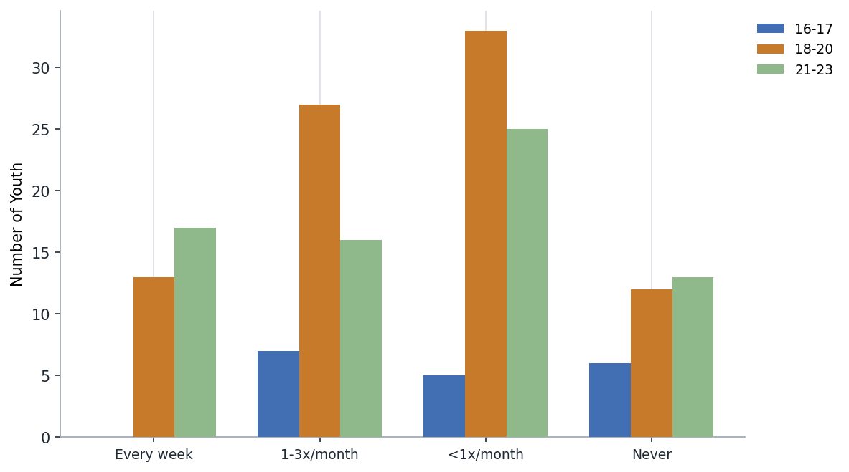
As in prior years, most youth who come at least monthly report coming to the 412 Youth Zone downtown to see their Youth Coach or other Zone staff (68%). Food (60%) and scheduled activities (58%) were also among the most common reasons for coming this year, ahead of working toward goals (54%). Among frequent visitors ages 21 to 23, 61% reported coming to be in a safe place and the same share reported coming to escape problems or issues, compared with 30% and 25%, respectively, of frequent visitors ages 18 to 20.
What Are the Main Reasons Youth Come to the Youth Zone?
Visit Reason (frequent visitors) | 16-17 years old | 18-20 years old | 21-23 years old | Unknown | Total
See my Youth Coach or other Zone Staff | 3 | 28 | 23 | 4 | 58
Eat food | 4 | 23 | 21 | 3 | 51
Participate in a scheduled activity | 4 | 23 | 18 | 4 | 49
Work toward my goals | 5 | 16 | 21 | 4 | 46
Learn new things, gain skills | 5 | 14 | 21 | 4 | 44
Be in a safe place | 4 | 12 | 20 | 3 | 39
Socialize/see friends | 5 | 12 | 15 | 3 | 35
Meet with service providers | 4 | 14 | 13 | 3 | 34
Escape problems/issues | 1 | 10 | 20 | 3 | 34
Do laundry, shower, etc. | 1 | 11 | 15 | 1 | 28
Health care and/or counseling | 1 | 10 | 12 | 1 | 24
Access to computers | 1 | 7 | 4 | 0 | 12
Other | 0 | 1 | 0 | 0 | 1
For youth who never visit the Zone, or visit less than monthly, the most common response for what would make them want to come more frequently was more activities that interest them (33%), followed closely by an invitation from their Youth Coach (30%) and knowing more about activities (26%). An invitation from a coach was especially salient for 18- to 20-year-olds, selected by 20 of 45 infrequent visitors in that age group. Open-text "other" responses most often referenced work or school schedules, transportation, and distance from the Zone.
What Would Make Someone Who Rarely Visits the Zone Want to Come, by Age
Visit Barrier (infrequent/never visitors) | 16-17 years old | 18-20 years old | 21-23 years old | Unknown | Total
Total respondents | 11 | 45 | 38 | 10 | 104
More activities that interest me | 5 | 14 | 12 | 3 | 34
Invitation from my Youth Coach | 0 | 20 | 9 | 2 | 31
Other | 2 | 9 | 15 | 3 | 29
Knowing more about activities | 3 | 10 | 14 | 0 | 27

Impact of Assistance
Across the core outcome areas in which Youth Zone staff are helping young people make progress, youth reported that their coaches and the Zone have helped them in a variety of ways. 80% of respondents indicated progress supported by the Zone in at least one area.
90% of respondents agreed or somewhat agreed that their coach or the Zone helped them stay focused on their goals.
My Coach or the Youth Zone has Helped Me To… (by Age)
Program Helped With | 16-17 years old | 18-20 years old | 21-23 years old | Unknown | Total
Think about my future | 9 | 53 | 37 | 8 | 107
Figure out how to handle problems | 6 | 37 | 30 | 7 | 80
Obtain vital documents | 6 | 28 | 28 | 4 | 66
Develop decision-making skills | 5 | 34 | 20 | 5 | 64
Establish positive relationships | 7 | 29 | 22 | 5 | 63
Find or maintain housing | 3 | 30 | 26 | 4 | 63
Get my driver's license | 6 | 23 | 21 | 7 | 57
Access health care/counseling | 3 | 23 | 21 | 0 | 47
Finish or further my education | 3 | 19 | 17 | 3 | 42
Get or keep a job | 4 | 18 | 14 | 6 | 42
Learn everyday skills | 1 | 21 | 10 | 1 | 33
Improve parenting skills | 2 | 6 | 9 | 2 | 19
Something else | 0 | 4 | 9 | 1 | 14
Respondents were asked to rate how often they felt respected and accepted for who they are at the Youth Zone. 89% of youth reported staff treat them with respect often or all the time; 76% said the same about their peers at the Zone.
Youth also rated five statements about the program environment on a 1–5 scale. Results are shown in terms of the percentage selecting 4 or 5 (top-2 box).

Banking
Participants were asked questions about their use of banks and other ways that they store, receive, and transfer money. Banking practices vary by age, with older youth more likely than 16- to 17-year-olds to report having an account. Overall, 66% of respondents reported currently having a bank account, down slightly from 69% in March 2025.
Nearly all youth who reported having an account also indicated they have a checking account (64% of all respondents), and 41% reported having a savings account. Digital payment apps such as Venmo, Zelle, and CashApp (53%) were used slightly more often than bank accounts themselves (52%) to store, receive, and transfer money, while 20% reported keeping cash at home.
Among youth with accounts, the most common uses were saving money (75%) and direct deposit (60%). Older account holders were also more likely to report using their accounts to pay household bills (48% of account holders ages 21 to 23), and 79% of youth who had an account but did not report using it to manage money said they rely on digital payment apps instead.
Banking Status by Age
Account Status | 16-17 years old | 18-20 years old | 21-23 years old | Unknown | Total | Percent of Total
Number of Youth | 18 | 88 | 72 | 26 | 204
Currently have a bank account | 11 | 65 | 54 | 4 | 134 | 66%
Checking account | 10 | 64 | 53 | 4 | 131 | 64%
Savings account | 9 | 40 | 32 | 2 | 83 | 41%
Had an account in the past | 0 | 5 | 7 | 0 | 12 | 6%
Never had an account | 5 | 18 | 7 | 0 | 30 | 15%
Methods Youth Use to Store, Receive, and Transfer Money, by Age
Money Method (Q24) | 16-17 years old | 18-20 years old | 21-23 years old | Unknown | Total | Percent of All
Venmo, Zelle, CashApp, etc. | 11 | 51 | 45 | 1 | 108 | 53%
Bank account | 9 | 50 | 45 | 2 | 106 | 52%
Saving/storing cash at home | 4 | 21 | 15 | 0 | 40 | 20%
PayPal | 0 | 10 | 14 | 0 | 24 | 12%
Check cashing service (ex. ACE) | 0 | 8 | 7 | 0 | 15 | 7%
Other | 0 | 2 | 6 | 1 | 9 | 4%
Money Order | 0 | 1 | 2 | 0 | 3 | 1%
Ways Respondents Use Their Bank Account(s), by Age
Account Usage (Q26b) | 16-17 years old | 18-20 years old | 21-23 years old | Unknown | Total | % of Account Holders
Saving money | 10 | 50 | 39 | 2 | 101 | 75%
Direct deposit | 5 | 31 | 44 | 1 | 81 | 60%
Keep my money safe | 7 | 36 | 33 | 1 | 77 | 57%
Transferring money | 7 | 32 | 29 | 2 | 70 | 52%
Budgeting money | 3 | 31 | 33 | 1 | 68 | 51%
Cashing checks | 8 | 32 | 24 | 1 | 65 | 49%
Bank credit/debit card | 6 | 30 | 27 | 1 | 64 | 48%
ATMs | 6 | 28 | 22 | 1 | 57 | 43%
Online banking/Bank app | 4 | 29 | 23 | 1 | 57 | 43%
Paying household bills | 2 | 15 | 26 | 1 | 44 | 33%
Banking in person | 1 | 11 | 12 | 0 | 24 | 18%
Writing checks | 0 | 12 | 8 | 0 | 20 | 15%
Other | 0 | 3 | 0 | 0 | 3 | 2%
None - I don't use my account | 0 | 0 | 1 | 0 | 1 | 1%
Youth were asked to rate on a scale of 0–10 how likely they would be to recommend the Youth Zone to a friend or family member. The Net Promoter Score (NPS) is 55. 69% of respondents were Promoters (9–10).
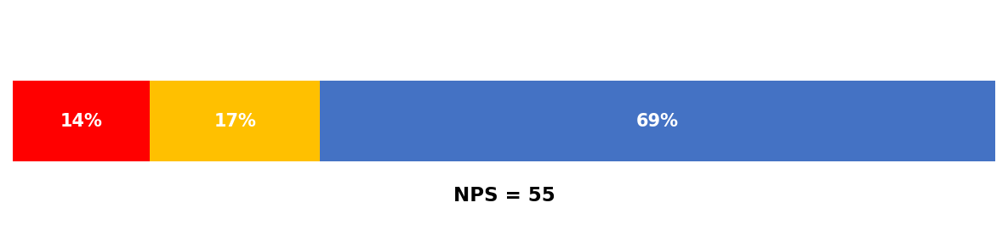

Additional Comments
Finally, youth had the option to share any other comments or feedback they had about the Zone. 53 youth provided additional comments.
As in March 2025, most substantive comments were positive and focused on appreciation for Youth Zone staff, coaches, and the support youth receive through the program. Of the 35 comments that provided more than a brief no/none response, many described staff as welcoming, helpful, and attentive, and several youth specifically said the Zone helped them feel safe, supported, or make progress toward their goals.
A smaller number of comments identified areas for improvement, most often around communication, access to resources such as driver's licensing help, or making activities easier to learn about in advance. A few quotes are included below as examples of the responses received.

Comments
- I like the YZ. I mainly attend planned activities, but have recently made more of an effort to come down just for socializing + fun more often. I prefer planned activities, or more knowledge of what will be happening ahead of time. Sometimes the website does not have all activities happening listed, and I only know by seeing them on the white board. I would like if the website listed all the activities. It would make it slightly easier to plan days to come down.
- I should utilize more the resources available.
- Sorry if my paper is confusing, it's my first time and I felt the need to clarify a lot of things
- No
- It's Cool.
- No comment All good
- Ms. Stephanie was very kind, knowledgeable, and welcoming. She showed she cared right away and she knows what she is doing. Helps me feel confident, safe, and willing to return.
- Not at the moment
- Not at this time.
- Very welcome & nice staff.
- NO
- Very nice, dedicated people who truly have a passion for people. Thank you.
- they help youth to developp in their Education
- All staff go out of their way to take interest in the youth participants clearly interest, life, problems, etc. They make us feel very heard especially Mrs. Darneisher Martin.
- No
- Fire morgan.
- A/k
- Why don't they help people really need
- I love the Youth Zone its and escape from home and its very helpful
- I want mister Javon to know im doing well
- I want that Gift CARD
- they help youth develop their education level and they have a good staff who takes care with respect
- thank you
- Mr. Will C is my favorite youth coach + Staff member along with Ms. Tamika C the one that calls Evce her neice + holds her)
- N/a
- nope
- Thank You
- NO
- YOUTH ZONE Saved My LiFe
- I Just Joined today, So I wasn't sure how to answer some of the questions.
- Very Great program, Awesome staff that are attentive & willing to help you meet your goals. Very helpful as well with resources and inviting you into a powerful community.
- NO
- No
- None.
- My journey with you guys has helped be with my adult life. Also has helped me change areas of my life, I was having difficulty with.
- Good program
- I need my drivers license
- I value them so much
- Nah I'm good thxs
- No
- Thank you :)
- My coach is better in terms of goat status than Tom Brady that's how clutch she is
- Thank you
- I wish it was available to kids who aren't just in cyf my friends that aren't in cyf want to join
- Communication should be a bit better. I feel like when I contact you soon through messenger they respond quicker and more attentively than my own Youth Coach.
- They are all amazing
- I had two coaches. I have nicollette first and I loved her. She's amazing and now I have meg and nicollette said she personally picked Meg because she knew that Meg and I would get along because our our combined interests! I love both of them very much and they both have helped me a lot!
- My youth coach is always too busy and doesn't make enough time for me
- Give my youth coach a raise! He's amazing!
- Appreciated a lot of things I wish I can stay in longer than 24
- No
- No
- Nope

